create a file in your project directory named .gitignore (**Note**: the name starts with a period)Then, add the following to the .gitignore file

now write : node_modules

in that file  
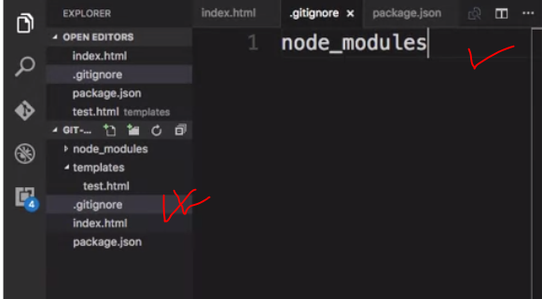

Then do a git commit and push the changes to the online repository. You will note that the node_modules folder will not be added to the commit, and will not be uploaded to the repository.